Assignment #1: Exploring Dikili Tash

Please visit the following website: <http://www.dikili-tash.fr/index_en.htm>

This website is the research page for the Dikili Tash archaeological project in northern Greece. Your assignment is to familiarize yourself with the Dikili Tash project by answering a series of questions that will help guide you through the history and archaeology of this little-known yet very important archaeological site.

Please answer **ALL QUESTIONS IN THE SPACE PROVIDED**. You may use point-form or full sentences. URL references are not required. This .docx file will allow you to type your answers into pre-set text boxes. Please do not alter the format of the document. Spend some time familiarizing yourself with the website by exploring the five section links: Presentation, Research, Chronology, Appendixes, and News.

Section 1: The Environment of Dikili Tash

1. Indicate on the map below the location of Dikili Tash (1pt).

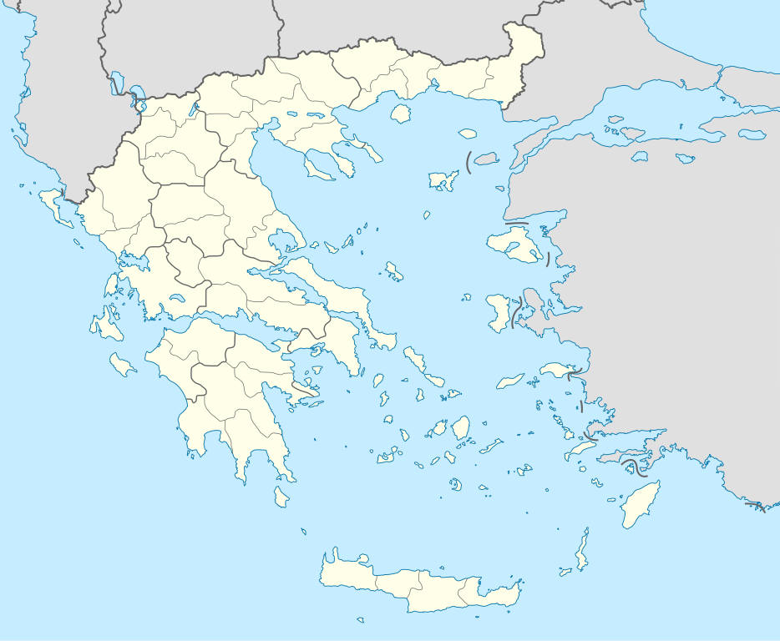

1. What is the specific name of the plain, administrative region, and regional unit in which Dikili Tash is situated? (hint: only one of these is on the website. You must determine the other two using outside sources) (3 pts).
2. Name the five mountain ranges surrounding Dikili Tash and their collective altitude range (3 pts)
3. What part of the plain was occupied and why (be specific)? (2 pts)
4. What advantage did Dikili Tash have over other nearby Neolithic sites, and why? (2 pts)

Section 2: Discovering Dikili Tash

1. Who is credited with discovering Dikili Tash and in what years? (2 pts)
2. What two archaeological features alerted researchers to this spot? (2 pts)
3. What material culture was first identified from Dikili Tash and where was it found? (2 pts)
4. Why is the nearby monolith partly destroyed? (2 pts)

Section 3: Excavating Dikili Tash

1. Name the research programs associated with Dikili Tash and when they were conducted (2 pts)
2. Aside from pottery, what were some of the first objects discovered during excavations at Dikili Tash? (2 pts)
3. There are four letters superimposed on the plan map of the Dikili Tash excavation trenches. What year-range was each associated excavation trench investigated? (4 pts)

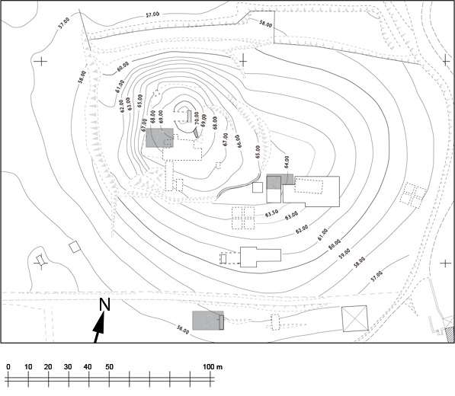

**A**

**D**

**C**

**B**

1. What did the results of the First Research Program (1961-1975) allow researchers to determine? What was their importance for understanding the archaeological record of the Balkans? (3 pts)
2. Geomorphological research was conducted during the Second Research Program (1986-1996). What did this research consist of and what did it provide? (4 pts)
3. Experimental archaeology is also conducted at the site of Dikili Tash. On what two aspects of ancient lifeways has this research predominantly focused? (2 pts)
4. What is this excavated feature? What period does it date to? Describe the likely construction technique (2 pts)

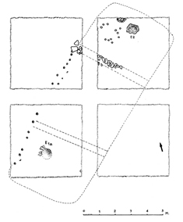

1. What is this feature? (1 pt)

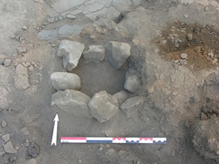

1. What is this feature (include cultural association) and where is it located on the site? (2 pts)

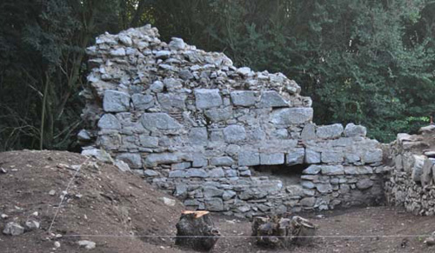

Section 4: Artifacts from Dikili Tash

1. What is this and what period does it come from? (2 pts)

Late Bronze Age flint blade: the dotted line indicates its axis of insertion in a “tribulum”.


1. What is this and what period does it come from? (2 pts)

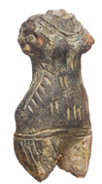

1. What is this and what period does it come from? (2 pts)

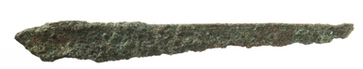

1. What is this artifact, what kind of decoration does it have, and what period is it from? (2 pts)

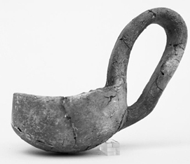

Section 4: Interpreting and Understanding Dikili Tash

1. Why did Dikili Tash enjoy a long continuity of occupation? (1 pt)
2. Examine the following profile of the Dikili Tash tell. What are the five predominant cultural periods that investigators believe are responsible for creating the tell? What are tells and how are they formed? (6 pts)

**A**

**E**

**D**

**C**

**B**

1. Around what year was Dikili Tash abandoned in the Bronze Age and what event did this abandonment correspond with in wider Greece? Use years BCE (2 pts)
2. When was Dikili Tash first occupied? Use years BCE (1 pt)
3. There is no evidence for which Bronze Age Period on Dikili Tash? (1 pt)

ASSIGNMENT GRADE: /60